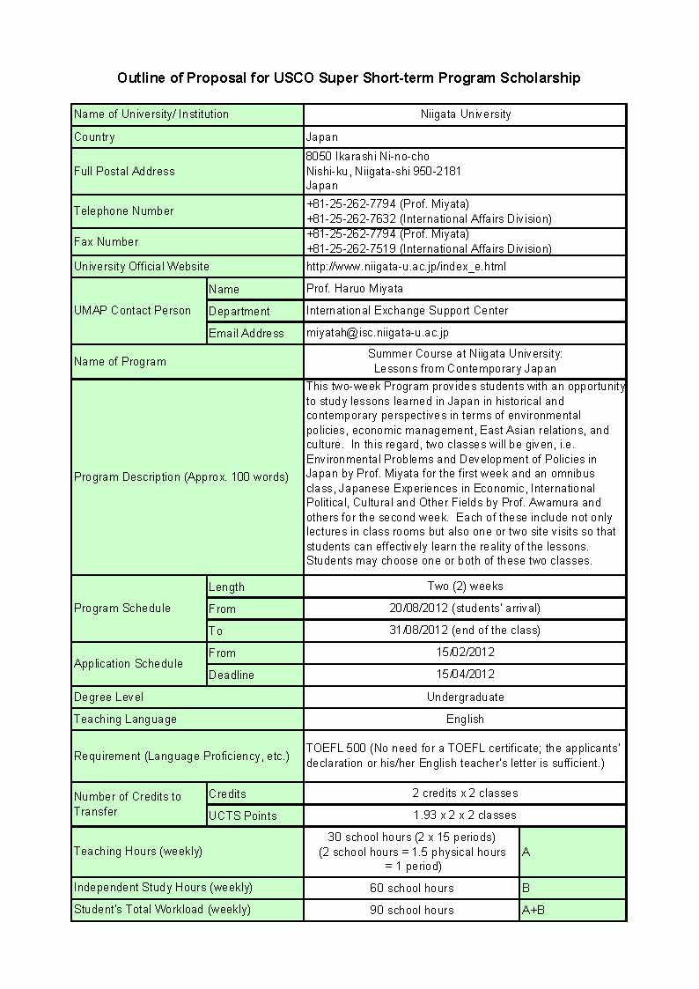
1. (Japan) Niigata University

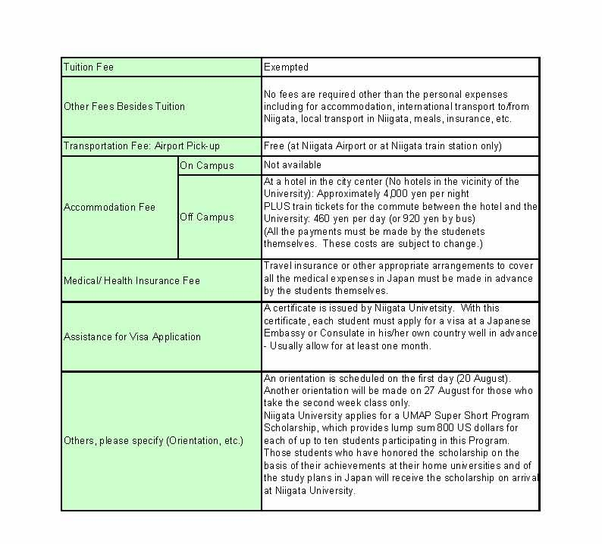

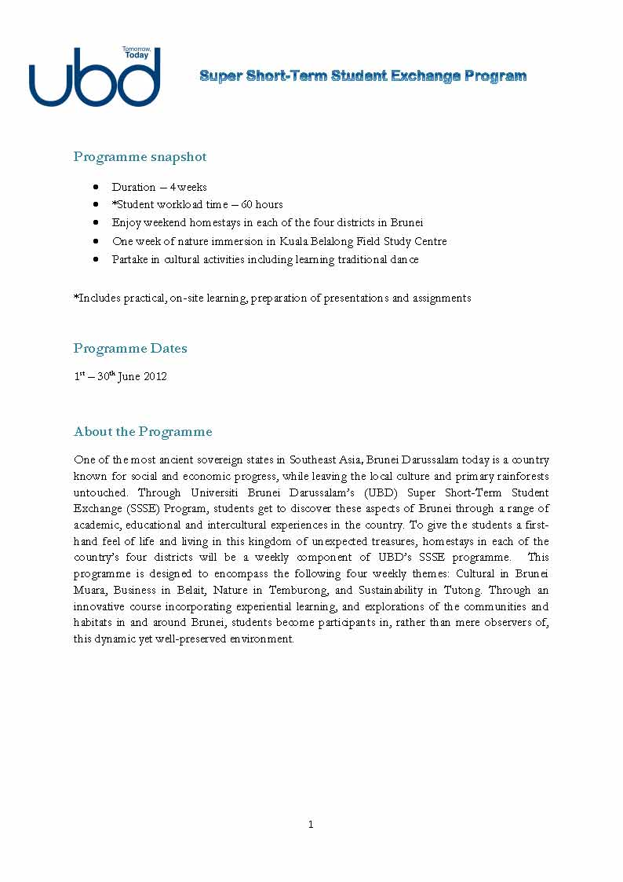
2. (Brunei) Universiti Brunei Darussalam

Programme snapshot
• Duration – 4 weeks
• *Student workload time – 60 hours
• Enjoy weekend homestays in each of the four districts in Brunei
• One week of nature immersion in Kuala Belalong Field Study Centre
• Partake in cultural activities including learning traditional dance
*Includes practical, on-site learning, preparation of presentations and assignments
Programme Dates
1st – 30th June 2012
About the Programme
One of the most ancient sovereign states in Southeast Asia, Brunei Darussalam today is a country known for social and economic progress, while leaving the local culture and primary rainforests untouched. Through Universiti Brunei Darussalam’s (UBD) Super Short-Term Student Exchange (SSSE) Program, students get to discover these aspects of Brunei through a range of academic, educational and intercultural experiences in the country. To give the students a first-hand feel of life and living in this kingdom of unexpected treasures, homestays in each of the country’s four districts will be a weekly component of UBD’s SSSE programme. This programme is designed to encompass the following four weekly themes: Cultural in Brunei Muara, Business in Belait, Nature in Temburong, and Sustainability in Tutong. Through an innovative course incorporating experiential learning, and explorations of the communities and habitats in and around Brunei, students become participants in, rather than mere observers of, this dynamic yet well-preserved environment.

Courses
Classes take place five days a week and depending on the courses, will range from lectures, group discussions, to field-oriented discovery trips.
The focus of the first week is culture and history and students will engage in lively classroom discussions with lecturers on topics such as the country’s national idology, the Malay Islamic Monarchy. Educational excursions include site visits to historical places of interest in the Brunei Muara district, culminating with a one-night stay at the historical Kampong Ayer where students get to interact with the locals, experience local cuisines, and live in ‘houses on water’.
The second week sees the students travelling by a speedboat along Brunei River to Bangar, Temburong district’s main town, before hopping onto a longboat along fast shallows and swirling rapids to the Kuala Belalong Field Studies Centre (KBFSC). The whole week spent in KBFSC will introduce students to one initiative which is close to Brunei’s heart: wildlife protection. Under closed supervision and guidance, students will study small mammals and their habitats in the forest. An optional component of this week is the Rainforest Canopy Walk, a suspension bridge that hangs 60m above the forest floor which puts students at eye level with some of the forest denizens and reported sightings include hornbills, macaques, and parrots, to name but a few.
The third week takes a look at the economic and industrial side of Brunei, introducing students to the concept of Islamic banking and finance through a series of lectures and group discussions. Given that the financial wellbeing of the Bruneians is largely owed to the country’s extensive oilfields, a field trip to the Belait district to have a feel of the Oil and Gas industry will hone students’ understanding of the country’s underground source of wealth. A one-night stopover in Kampong Balai, a village that was once the hub of the traditional industry of sago processing, entails sleeping in a traditional wooden warrior house which the locals call “Skada Puak Belait”.
The fourth week centres on the notion of sustainability and biodiversity in the Tutong district and will be examined through site visits and lectures by experts in these areas. A three-night stay in Tasek Merimbun, a park on the list of ASEAN Heritage Parks and Reserves, include studying pitcher plants and bats in the Tutong area, as well as a one-day practical on forest ecology. One of the main attractions of Tasek Merimbun is the freshwater lake which supports a variety of fish and fauna, and students get a chance to learn about the species endemic to the region.

Programme Weekly Overview – Week 1: Brunei Muara

 |  | Morning | Late Morning | Afternoon | Evening
Week 1 | Day 1 | Welcoming Ceremony | Ice-breaker Session | Campus Tour | Site Visit: Tamu Gadong
Week 1 | Day 2 | Introduction to Brunei Darussalam (Lecture) |  | Brunei Darussalam: A Malay Islamic Monarcy (Lecture) | Brunei Mangrove Night Safari & Welcoming Dinner at Brunei Waterfront
Week 1 | Day 3 | Languages and Cultures in Brunei (Lecture) |  | Site Visit: Royal Regalia Museum; Brunei National Museum | Preparation for Group Presentation
Week 1 | Day 4 | Group Presentation | Group Presentation | Group Presentation | Free & Easy
Week 1 | Day 5 | Free & Easy |  | Activities arranged by Student Clubs
Week 1 | Day 6 | Departs for Kampong Ayer |  | Homestay at Kampong Ayer
Week 1 | Day 7 | Site Visit: Kampong Ayer, the Kampong Ayer Gallery, Omar Ali Saifuddien Mosque, Sultan Bolkiah's Tomb, Bubongan Duabelas |  | Back to UBD | Free & Easy

Programme Weekly Overview – Week 2: Temburong
 |  | Morning | Late Morning | Afternoon | Evening
Week 2 | Day 1 | Depart Bandar Seri Begawan |  | Arrive in KBFSC; Briefing on Rules & Regulations of Centre | Briefing on KBFSC
Week 2 | Day 2 | Hands-on Learning of Small Mammal Biodiversity in a Rich Dipterocarp Forest in Brunei (A Series of Practical & Lectures)
Week 2 | Day 3
Week 2 | Day 4
Week 2 | Day 5
Week 2 | Day 6
Week 2 | Day 7 | Optional Visit to Canopy Walkway | Leave KBFSC | Free & Easy

Programme Weekly Overview – Week 3: Belait
 |  | Morning | Late Morning | Afternoon | Evening
Week 3 | Day 1 | Islamic Banking & Finance in Brunei (Lecture) |  |  | Activities arranged by Student Clubs
Week 3 | Day 2 | Islamic Banking & Finance in Brunei (Lecture) |  |  | Preparation of Assignments
Week 3 | Day 3 | Site Visit: iCentre, Brunei Economic Development Board, Agrotech Park |  |  | Preparation of Assignments
Week 3 | Day 4 | Islamic Banking & Finance in Brunei (Lecture) |  | Assignments | Free & Easy
Week 3 | Day 5 | Site Visit: Sungai Liang Methanol Park (SPARK), Brunei Shell Petroleum, Billionth Barrel, Oil & Gas Discovery Centre |  |  | Overnight Stay at Rumah Kerajaan
Week 3 | Day 6 | Departs for Kampong Kuala Balai | Activities in Kampong Kuala Balai
Week 3 | Day 7 | Activities in Kampong Kuala Balai |  | Back to UBD | Free & Easy

Programme Weekly Overview – Week 4: Tutong
 |  | Morning | Late Morning |  | Afternoon |  | Evening
Week 4 | Day 1 | Depart for Tasek Merimbun (Homestay) |  |  | Activities in Tasek Merimbun
Week 4 | Day 2 | Forest Ecology (Practical)
Week 4 | Day 3 | Animal-Plant Interactions: How Organisms Depend on Each Other (Practical) |  | Animal-Plant Interactions: How Organisms Depen on Each Other (Lecture) |  | Activities in Tasek Merimbun
Week 4 | Day 4 | Sustainable Environments (Practical & Lecture) |  |  | Back to UBD/Free & Easy
Week 4 | Day 5 | Preparation for Assignments
Week 4 | Day 6 | Assignments & Reflections |  |  | Free & Easy
Week 4 | Day 7 | Farewell Ceremony

Cost of UBD SSEA Programme

Mandatory Costs paid to UBD per Student
Application Fee | USD100
Programme Fee (Includes accommodation at UBD's The Core residential college at a rate of USD38 / night) | USD5420
Prepaid Site Visit Fee (Includes guides, on-site transportation, costs of homestays) | USD1400
Sub-Total | USD6920

Other / Estimated Costs
Meals (Estimated for purchased meals) | USD250
On-Site Site Visit Costs (Estimate for entrance fees) | USD50
Medical Travel Insurance (Students must provide evidence of medical travel insurance coverage) | Variable
Miscellanous Expenses (Students must budget for personal miscellanous expenses (e.g. gifts)) | Variable
Sub-Total | USD300*
*This figure does not include mandatory Medical Travel Insurance.

Approximate TOTAL cost of programme = USD7220

3. (Mongolia) National University of Mongolia

敬請參考：
http://news.num.edu.mn/wp-content/uploads/2012/01/Summer-school-2012-Brochure-Irmuun-Final3.pdf

4. (Vietnam) Vietnam National University, Hanoi(VNU)

Outline of Proposal for USCO Super Short-term Program Scholarship
Vietnam National University, Hanoi (2012)
Name of University/ Institution |  | Vietnam National University, Hanoi - University of Engineering and Technology
Websites: |  | http://vnu.edu.vn/eng/ and http://e.uet.vnu.edu.vn/
Country |  | Vietnam
Full Postal Address |  | 144 Xuan Thuy, Cau Giay, Hanoi, Vietnam
Telephone Number |  | (+84 4) 37547865
Fax Number |  | (+84 4) 37547460
University Official Website |  | http://www2.uet.vnu.edu.vn/coltech/
UMAP Contact Person | Name | Ms. LE Thi Phuong Thoa
UMAP Contact Person | Department | Academic Affair
UMAP Contact Person | Email Address | Thoaltp@vnu.edu.vn
Name of Program |  | Earning Credit and Discovering Vietnamese Culture
Program Description (Approx. 100 words) |  | The program includes three different courses: Electrical Engineering (ELT 2030), Computer Communications Networks 1 (ELT3046) and Data mining (INT3103) that student can choose. Besides, student will have opportunities to discover Vietnamese sightseeings and culture by visiting Halong Bay,Thang Long Old Castle and 36 Streets Old Quarter.
Program Schedule | Length | 4 weeks
Program Schedule | From | 2012/7/15
Program Schedule | To | 2012/8/15
Application Schedule | From | 2012/5/15
Application Schedule | Deadline | 2012/6/30
Degree Level |  | Bachelor's
Teaching Language |  | English
Requirement (Language Proficiency, etc.) |  | IELTS 5,5
Number of Credits to Transfer | Credits | 3 credits/ course
Number of Credits to Transfer | UCTS Points | 3 UCTS Points
Teaching Hours (weekly) |  | 7,5 hours | A
Independent Study Hours (weekly) |  | 15 hours | B
Student's Total Workload (weekly) |  | 22,5 hours | A+B
Tuition Fee |  | 750.000 VNĐ ( equivalent to $40 per course)
Other Fees Besides Tuition |  | $100 activity fee (including Tour fee)
Transportation Fee: Airport Pick-up |  | $40 (round trip)
Accommodation Fee | On Campus | 50-100$/mounth/student
Accommodation Fee | Off Campus | 100-200$/month/student
Medical/ Health Insurance Fee |  | Students should buy tourist insurance from their home country.
Assistance for Visa Application |  | 50-100$
Others, please specify (Orientation, etc.) |  | - Total Cost: 280 - 480$/ student  - Syllabus of each course  - Program in details - Studying and SightSeeing Agenda

5. (Philippines) Mariam College
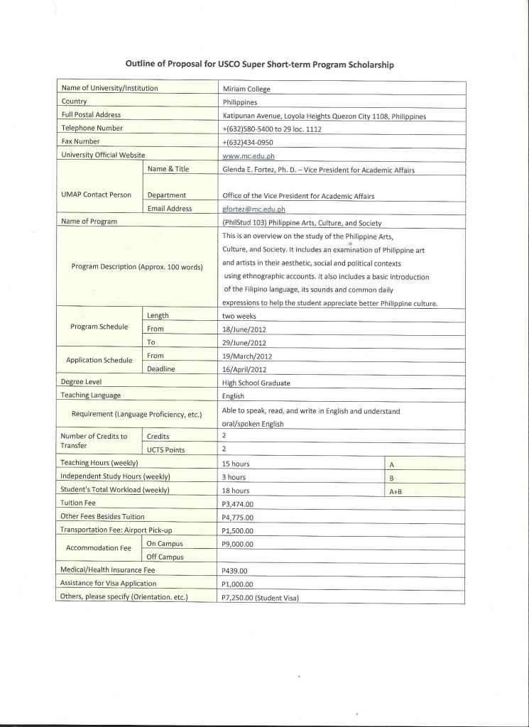

7. (Thailand) Payap Universit
6. (Philippines) Lyceum of the Philippines University- Batangas

Center for Language Learning (CELL)

Description: Tutorial/Short Courses
Duration: 20 hours
(or depending upon the needs of the client)
Fees: Tutorial (one on one): 4,800.00 Php.
Short course (2 pax) - 2,500.00 Php. each
(3 – 10 pax per group) – 2,000.00 Php each
Facilities & Equipment Utilized: DynEd Lab, Classroom, Library

The Lyceum of the Philippines University Center for Language Learning (CELL) is a facility that operates under the College of Education, Arts, and Sciences. This offers tutorial and short courses which cater to all students in their pursuit of improving their language proficiency with focus on English. Short intensive one-on-one or group courses which are limited to 10 persons per group are offered for beginners, intermediate, or advanced learners. Students will learn and use new language forms and vocabulary through practice in contemporary, realistic, everyday work-related situations.

Topics/Activities include:
- Vocabulary Enhancement
- Reading Enhancement
- Writing Enhancement
- Grammar and Structure of English
- Listening Enhancement
- Speaking Enhancement
- Testing Oral English
- Testing Written English
- listening skills
- conversational skills
- giving feedback
- meeting skills
- presentation skills
- conflict resolution skills
- negotiation skills
- training skills
- persuading skills
- promoting one’s own strengths and abilities

- (Thailand)Bangkok University
 |  |  |  | Thailand
  Country
 |  |  |  | Bangkok University, Rama 4 Road, Klong Toey, Bangkok 10110, Thailand
  Full Postal Address
 |  |  |  | +66-2-902-0299 ext. 2163, 1164
  Telephone Number
 |  |  |  | +66-2-240-1819
  Fax Number
 |  |  |  | www.bu.ac.th
  University Official Website
 |  |  |  | Dr. Siriwan Ratanakarn  Assistant to the President for Academic Affairs
  UMAP Contact Person
  Name & Title
 |  |  |  | Academic Affairs
  Department
 |  |  |  | siriwan.r@bu.ac.th
  Email Address
 |  |  |  | BR 305 Broadcast Production Techniques
  Name of Program
 |  |  |  | This course focuses on the theories and practices on the broadcast production techniques. Hand-on extensive training on how to use the equipments and software as well as field work are included.
  Program Description (Approx. 100 words)
  Program Schedule
  Length
  3 weeks
  From
  24/10/2012
  To
  14/11/2012
  Application Schedule
  From
  1/08/2012
  Deadline
  31/08/2012
 |  |  |  | Undergraduate (Third-Year) Level
  Degree Level
 |  |  |  | English
  Teaching Language
 |  |  |  | -
  Requirement (Language Proficiency, etc.)
 |  |  |  | 3
  Number of Credits to Transfer
  Credits
 |  |  |  | 2
  UCTS Points
 |  |  |  |  | 45 hours
  Teaching Hours (weekly)
  hours
  A
 |  |  |  |  | 15 hours
  Independent Study Hours (weekly)
  hours
  B
 |  |  |  |  | 60 hours
  Student’s Total Workload (weekly)
  hours
  A+B
 |  |  |  | US $ 360 per person
  Tuition Fee
 |  |  |  | Orientation & Team Building Activities US $ 24 per person  Field Trip US US $ 40 per person  Inter-campus shuttle service US $ 100 per person
  Other Fees Besides Tuition
 |  |  |  | US $ 25 per person
  Transportation Fee: Airport Pick-up
 |  |  |  | -
  Accommodation Fee
  On Campus
 |  |  |  | US $25 (double room)  US $43 (single room)
  Off Campus
 |  |  |  | -
  Medical/ Health Insurance Fee
 |  |  |  | Yes
  Assistance for Visa Application
Others, please specify (Orientation, etc.)

8. (Thailand) Payap University- Intensive Thai Program

INTENSIVE THAI
Course Descriptions

Thai 1
(Prerequisite: None) This course is designed for learners who had no background knowledge of the Thai language. It emphasizes improving learners’ oral language competence. Topics are related to daily life.

Thai 2
(Prerequisite: Thai 1 or by placement) This course is a continuation of Thai 1 with a focus on developing learners’ listening and speaking skills with an emphasis on conversation in other situations than those learned in Thai 1.

Thai 3
(Prerequisite: Thai 2 or by placement) An introduction for reading and writing system of the Thai language to extend learners’ ability in communication, including the expression of ideas and feeling.

Thai 4
(Prerequisite: Thai 3 or by placement) A continuation of Thai 3 focusing on using the Thai language in various situations. This course emphasizes the development of learners’ four language skills, with an emphasis on practicing speaking in order to express ideas, practicing writing essays on various topics.

Thai 5
(Prerequisite: Thai 4 or by placement) A continuation of Thai 4 focusing on using the Thai language in various situations. This course emphasizes the development of learners’ four language skills, with an emphasis on developing skills in reading newspapers, different kind of news, magazines, and other printed materials.

Thai 6
(Prerequisite: Thai 5 or by placement) A continuation of Thai 5 focusing on using the Thai language in various situations. This course emphasizes the development of learners’ four language skills. The course aims to develop learners’ ability in comprehending what they read and respond to it in a form of speaking or writing.

Thai 7
(Prerequisite: Thai 6 or by placement) A continuation of Thai 6 focusing on using the Thai language in various situations. This course emphasizes the development of learners’ four language skills. This course continues to emphasize listening and speaking for academic or higher communications purposes. The course aims to develop learners’ ability in comprehending what they read and respond to it in a form of speaking or writing.

Thai 8
(Prerequisite: Thai 7 or by placement) A continuation of Thai 7 focusing on using the Thai language in various situations. This course emphasizes the development of learners’ four language skills. This course continues to emphasize listening and speaking for academic or for higher communication purposes. The course aim to develop learners’ ability in comprehending what they red and respond to it in a form of speaking or writing. Class will emphasize the development of literacy skills including identifying main idea, reference, guessing meaning using context clues, etc.

Thai 9
(Prerequisite: Thai 8 or by placement) A continuation of Thai 8 focusing on using the Thai language in various situations. This course emphasizes the development of learners’ four language skills, with an emphasis on developing skills in reading Thai literature, such as tales, short stories and other literary writings.

Thai 10
(Prerequisite: Thai 9 or by placement) A continuation of Thai 9 focusing on using the Thai language in various situations. This course emphasizes the development of learners’ four language skills. The course emphasizes not only language development but also college study skills. Various language learning strategies will be introduces, at the same time learners’ reading and writing skills are also emphasized. Extensive reading in the student’s interest or field of study is required.

Intensive Thai Program
Academic Year 2012 (June 2012 to May 2013)

Term | Course | From | To | Length
1 | Thai 2, Thai 4, Thai 6, Thai 8 | 5 June 2012 | 2 July 2012 | 60 hrs
2 | Thai 1, Thai 3, Thai 5, Thai 7 | 9 July 2012 | 7 Aug. 2012 | 60 hrs
3 | Thai 2, Thai 4, Thai 6, Thai 8 | 20 Aug. 2012 | 14 Sept. 2012 | 60 hrs
4 | Thai 1, Thai 3, Thai 5, Thai 7 | 24 Sept. 2012 | 19 Oct. 2012 | 60 hrs
5 | Thai 2, Thai 4, Thai 6, Thai 8 | 5 Nov. 2012 | 30 Nov. 2012 | 60 hrs
6 | Thai 1, Thai 3, Thai 5, Thai 7 | 7 Jan. 2013 | 1 Feb. 2013 | 60 hrs
7 | Thai 2, Thai 4, Thai 6, Thai 8 | 4 Feb. 2013 | 1 Mar. 2013 | 60 hrs
8 | Thai 1, Thai 3, Thai 5, Thai 7 | 11 Mar. 2013 | 5 Apr. 2013 | 60 hrs
9 | Thai 2, Thai 4, Thai 6, Thai 8 | 22 Apr. 2013 | 17 May 2013 | 60 hrs

Classes
Classes are conduct between the hours of 9.00 a.m. – 12.00 p.m. Mondays to Fridays (except public holiday).

8. (Thailand) Payap University- Thai & South East Asian Studies

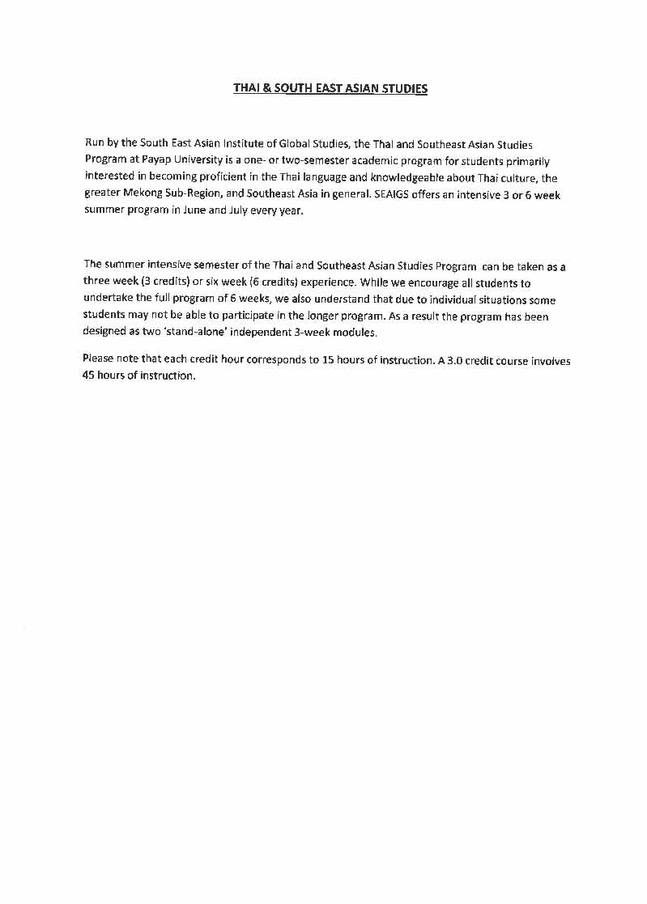

Summer 2012: Monday, 11 June (MODULE 1) & Monday, 2 July to Friday, 20 July (MODULE 2), (Campus Arrival Dates for MODULE 1: Friday-Saturday, 8-9 June 2012 & MODULE 2: Friday –Saturday, 29-30 June 2012)South East Asian Institute of Global Studies (SEAIGS) summer course offerings:

MODULE 1 CLASSES ( Monday, 11 June to Friday, 29 June)
Cultural Foundations of Thai Society (3 credits)
Academic Discipline: Social Science & Environmental Studies
This course introduces students to Thailand through a general survey of topics on Thai culture and society. The course combines classroom lecture and discussion with a variety of field experiences in Chiang Mai and Northern Thailand. It will focus on the changes and continuity of cultural practices and the major institutions of the country. Themes to be analyzed include history, politics, customs, and identity. This course will also spend significant time examining ecological, social, and economic transitions now underway in Mainland Southeast Asia with emphasis on Northern Thailand. Class presentations and field studies will examine how semi-wild landscapes and traditional cultures are being affected by infrastructure development and increasing reliance on the market as a source of livelihood.
Considering that 'development' will continue to be an integral component of the human enterprise in the foreseeable future, we will explore strategies to reduce the ecological and social costs of this activity in Thailand and Southeast Asia.
Students should be prepared for challenging individual and group activities outside the classroom. The course includes field trips and a short-term village home stay which provides an enriching insight into many different walks of life in Thailand.
Buddhism in Southeast Asia (3 credits)
Academic Discipline: Religious Studies/Social Sciences
Buddhism has been a significant force in the culture and life ways of Southeast Asian peoples. This course will examine Theravada Buddhism both as a doctrine and practice originating in India and as a socio-cultural reality that shapes the lives of Southeast Asian people and has in turn been molded by their culture and history. The basic doctrines, key institutions and core value orientations of Theravada Buddhism as they function in Thai and Southeast Asian societies will be analyzed. The approach will draw on a variety of social science concepts and theoretical perspectives. While focused on the Thai experience the role of Theravada and Mahayana Buddhism in Myanmar, Cambodia and Vietnam will also be examined.

MODULE 2 CLASSES (Monday, 2 July to Friday, 20 July)
Human Rights in Southeast Asia (3 credits)
Academic Discipline: Political Science
This three week intensive course will examine why human rights abuses are possible on such an enormous scale and with such terrible intensity in Southeast Asia and, in particular, Myanmar (Burma; notorious for its military government), either through direct mistreatment or criminal neglect of the population. Given the rise of Asian powers like China and India in what has been dubbed the "New Asian Hemisphere," Southeast Asia, located between two giants, is the perfect place to study the intersection of all that has gone amok in Asian politics. This course will bring us up to date through the systemic and systematic abuses of human rights in Burma, especially since the pro-democracy uprising of 1988 and culminating in the 2007 Saffron Revolution and the run-up to the 2010 election in Burma, otherwise known as Myanmar.
The focus is on Burma, but we will contextualize this case study within the broader region of Southeast Asia and analyze other countries' experiences toward transition and a free market economy. We will compare Burma's human rights situation with that in other countries, including Iraq, Pakistan, China, the USSR Hitler's Germany and North Korea. We will also look at human rights in other parts of Southeast Asia as well as examine the internationalization of the Burma crisis and the role of the Association of South East Asian Nations (ASEAN).
What has happened in Burma? Did the top-down controlled command economy destroy the country? What is the administrative structure of this notorious military dictatorship, one of the world's most notorious rogue states? How is Burma changing in the wake of political reforms implemented in 2011 and 2012? No prior knowledge of Burma or Southeast Asia is required for this course. A passionate commitment to human rights and an open mind, however, is a must.
The Economics of the Sex Industry in Southeast Asia (3 credits)
Academic Discipline: Economics/Social Science
This course will examine the 'oldest' industry in the world from an economics perspective, within the Southeast Asia region. Specifically, the course will investigate cultural and religious factors of this region and how these factors may influence the demand side and supply side of the market. Other topics covered in the course include the market structure, government regulation and the resulting policy implications. Special topics unique to the regions such as child prostitution, human trafficking for the purpose of prostitution, and sex work and sex tourism will also be discussed.

- (Taiwan)Tzu Chi College of Technology

Outline of Proposal for USCO Super Short-term Program Scholarship
Name of University/ Institution |  | Tzu Chi College of Technology
Country |  | Taiwan
Full Postal Address |  | 97003
Telephone Number |  | +886-3-8572158 Ext: 479
Fax Number |  | -8464530
University Official Website |  | http://www.tccn.edu.tw/front/bin/home.phtml
UMAP Contact Person | Name | Yung-Lun Tsai
UMAP Contact Person | Department | Research and Development Center
UMAP Contact Person | Email Address | rndcop11@tccn.edu.tw
Name of Program |  | Transcultural service-learning Program
Program Description (Approx. 100 words) |  | The program has two themes: culture and service learning. It offers a great opportunity for students to know Taiwanese culture, humanity, as well as practice service learning overseas. Course activity includes taking calligrapgy, flower arranging, meditation, tea appreciation, aborginal dance courses; making Taiwanese foods; visiting temple; observing living environemnt; doing street clearning, recycling, and cleaning up litter. We have provided similar program for our sister schools for several years and had receive very positive feedback from them. We hope to extend the learning opportunity to students from different schools and countries.
Program Schedule | Length | 4 weeks
Program Schedule | From | Aug. 2012
Program Schedule | To | Aug. 2012
Application Schedule | From | Apr. 2012
Application Schedule | Deadline | Apr. 2012
Degree Level |  | Undergraduate
Teaching Language |  | English
Requirement (Language Proficiency, etc.) |  | Basic communication ability
Number of Credits to Transfer | Credits | 2
Number of Credits to Transfer | UCTS Points | 2
Teaching Hours (weekly) |  | 9 hours/week | A
Independent Study Hours (weekly) |  | 6 hours/week | B
Student's Total Workload (weekly) |  | 15 hours/week | A+B
Tuition Fee |  | US $100
Other Fees Besides Tuition |  | Vegetarian meal: 4 per day (on campus)
Transportation Fee: Airport Pick-up |  | about US $40 (round-trip ticket)
Accommodation Fee | On Campus | US $4 per day
Accommodation Fee | Off Campus | NA
Medical/ Health Insurance Fee |  | US $40
Assistance for Visa Application |  | Invitation letter
Others, please specify (Orientation, etc.) |  | 1.Provide vegetarian only in school 2.Our school is in the eastern Taiwan, so afeter students arrive Taiwan, they need to take public transportation(ie. high speed rail and railway) to arrive the school . It cost about US $40 (round-trip ticket). 3. Although we are Buddhist school, we resect students with different religions.

10. (Taiwan) Kun Shan University



